# Workshop 6 - Week 8 - CSY2085 – Server Administration and Security

## Workshop: Linux Server VM on Google Cloud

## Getting Google Cloud Credit

STUDENT NAME: Muhammad Raza

STUDENT NUMBER: 21624838

## Task 1 - Creating a Ubuntu VM Instance on Google Cloud

1. Capture your Server screen and paste it here

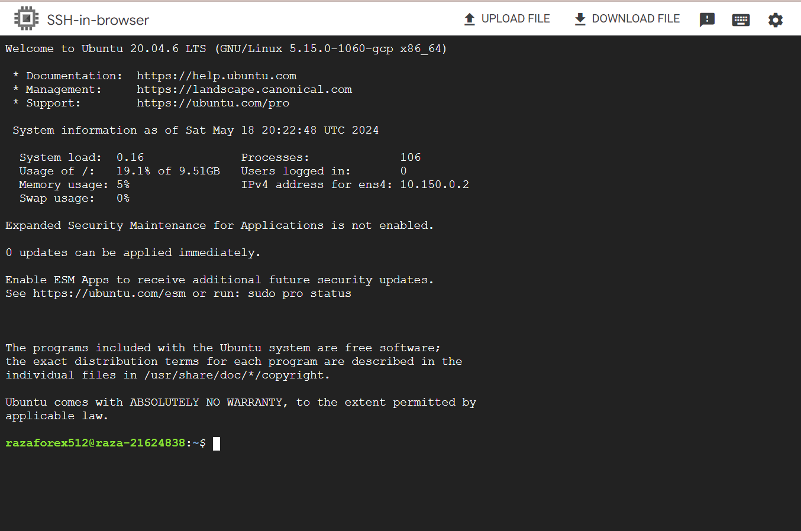

1. Go Back to the Google Cloud Console and take a note of your server’s IP Addresses shown there.

**Internal IP address: 10.150.0.2**

**External IP address: 34.86.26.253**

**Question: What’s the significance of these two addresses?**

The internal IP address (10.150.0.2) is used for communication within the virtual network, ensuring private and secure connections between VMs. The external IP address (34.86.26.253) allows access from the internet, enabling external users to connect to the VM.

**How do you display the IP address in the Linux shell?**

To display the IP address, you can use the command ifconfig after installing net-tools with sudo apt install net-tools.

1. Capture your screen and paste it here

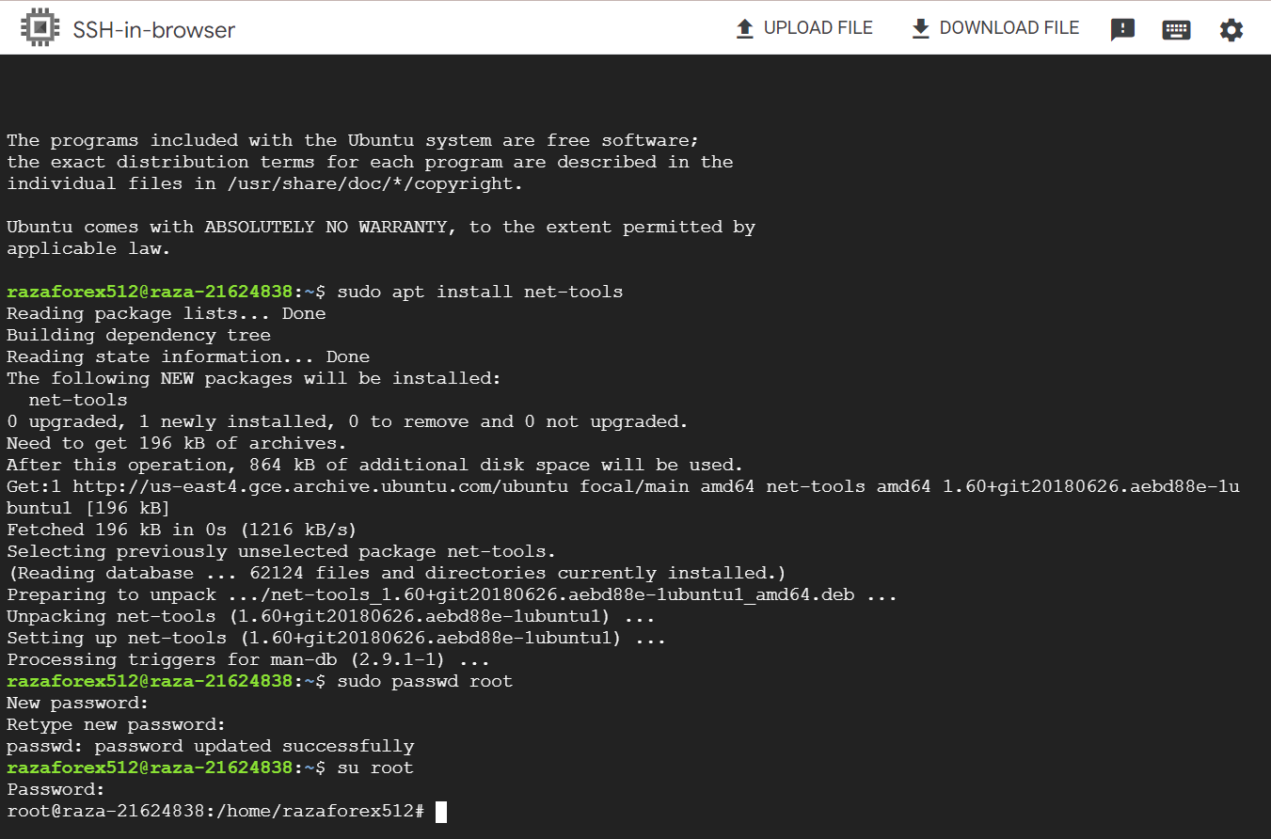

## Task 2 - Linux Bash Shell Commands

Capture the screen, showing the new user and their group   
  
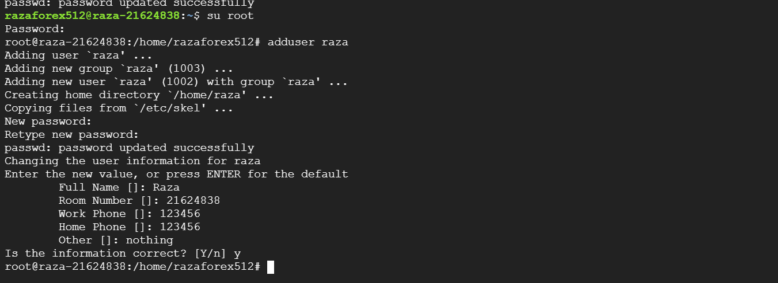

* 1. Capture the screen, showing the new user’s details, and paste the screen below:  
       
     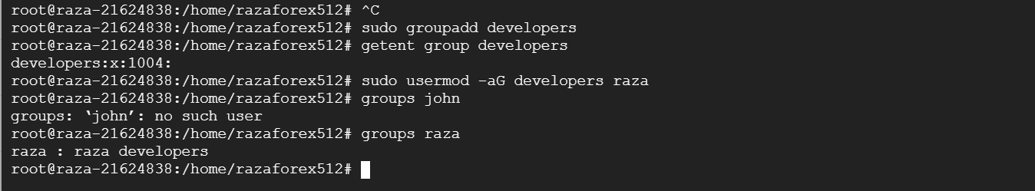  
       
     **Question: Could you do this, and why?**   
     No, you couldn't access the restricted directory **/root** because normal users do not have permission to view root's files without elevated privileges.  
       
     Capture the screen, showing the sudoers file:

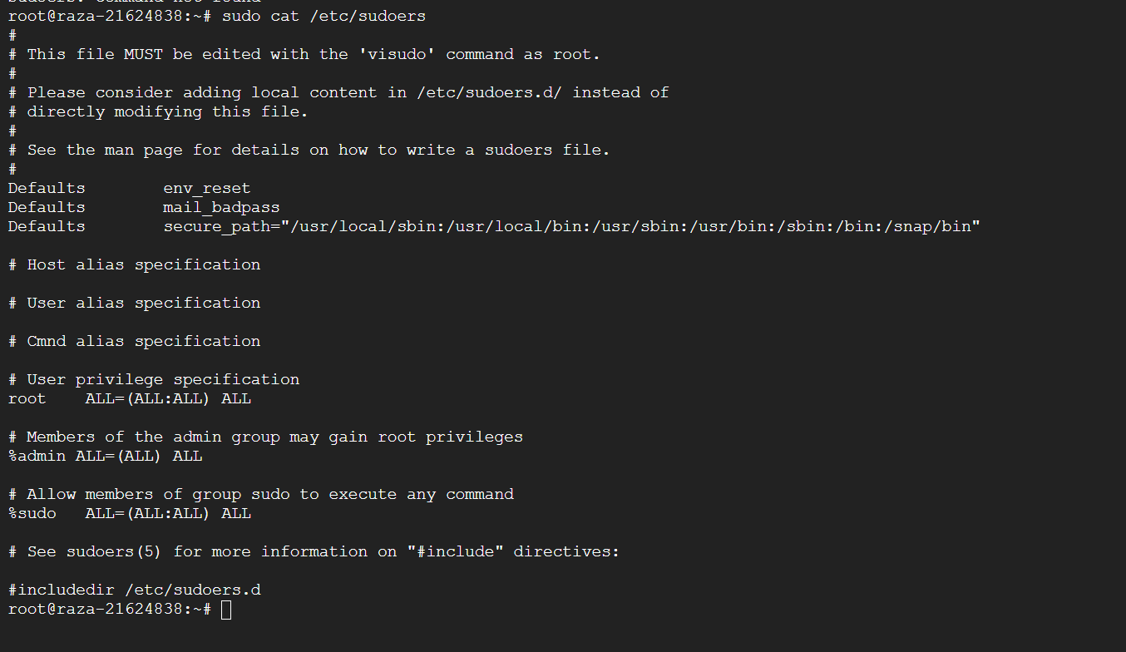

* 1. Capture the screen, showing the root user's files and paste the screenshot below:  
     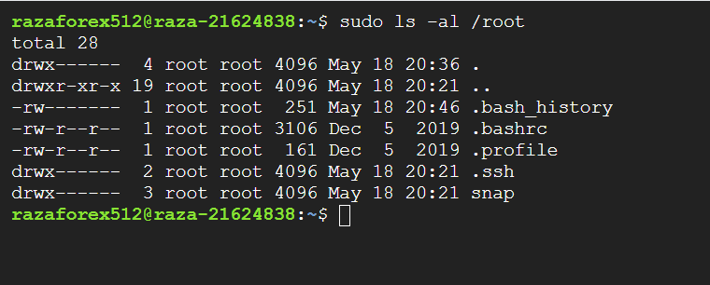
  2. You should now get a display of the directories and files that you have just created in a tree-like structure:  
     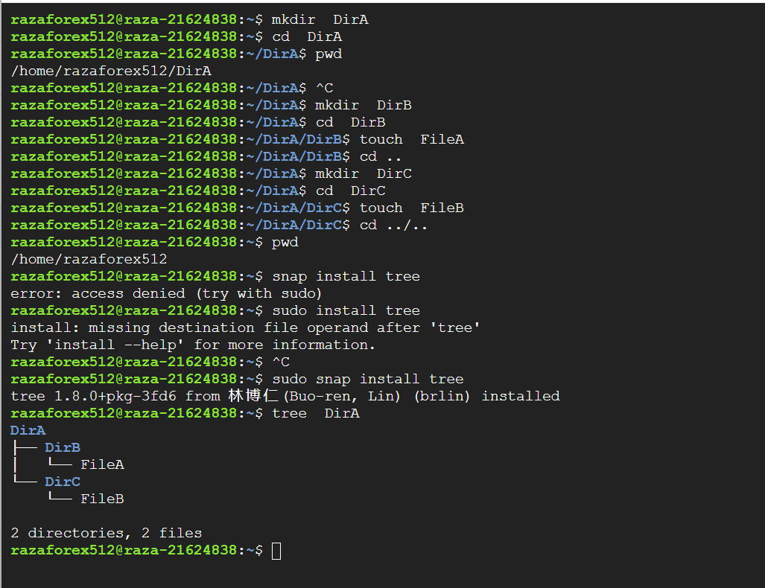
  3. Now, using the same commands that you have just learnt, create the following directory arrangements:

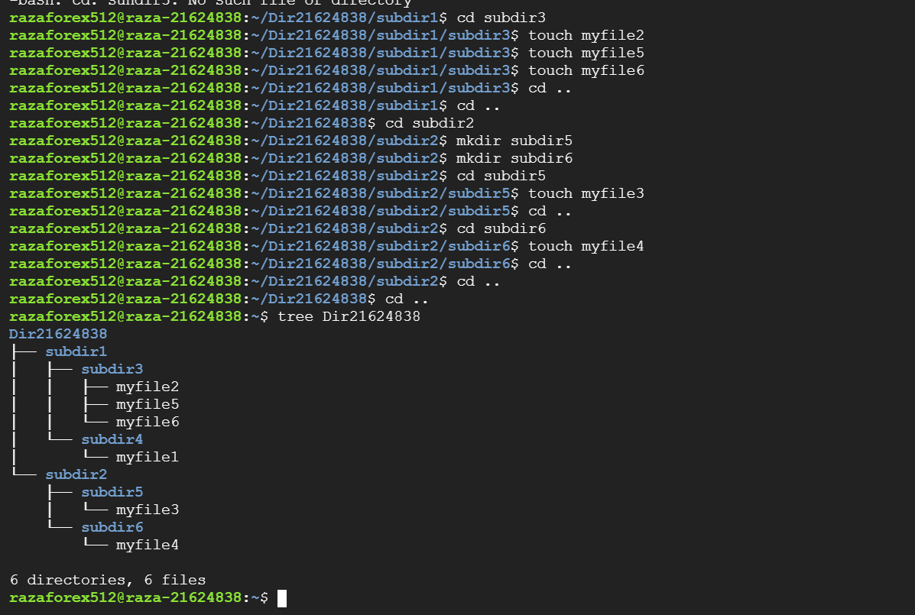  
**Final Questions:**

1. Why do you think we are managing the Linux server in text mode rather than graphical mode? (Write what you think.   
   Managing the Linux server in text mode is more resource-efficient, provides greater control, and is essential for environments without graphical interfaces. It's also the standard for server management and automation.
2. What are the advantages of having your server on the cloud? What are the disadvantages?

Advantages: Scalability, cost-efficiency, accessibility from anywhere, and reduced physical hardware maintenance. Disadvantages: Potential security risks, reliance on internet connectivity, and possible downtime due to service provider issues.